3. Adjusting Entries: 7. Reverse Penalty Calc’d on a Date

Before you continue, you will want to print or preview a Detail Transaction report from the Reports Menu.

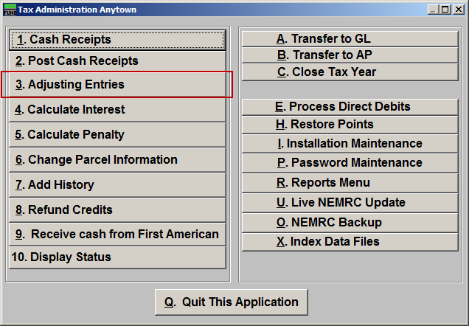
Click on “3. Adjusting Entries” from the Main Menu and the following window will appear:

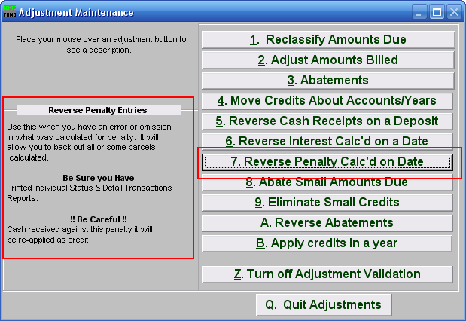
Consider the description that appears when you place the mouse over “7. Reverse Penalty Calc’d on Date.” Click “1. Reclassify Amounts Due” and the following window will appear:

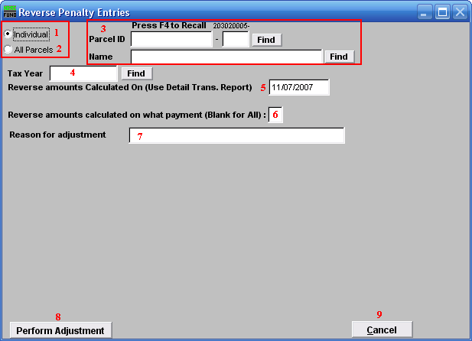
- Individual: Click to choose this option if you want this adjustment to be for an Individual Parcel.

- All Parcels: Click to choose this option if you want this adjustment to be for all Parcels.

- These fields are only available if you chose “Individual.” Select the Parcel you are seeking. For additional information on finding Parcels, refer to TA GENERAL PARCEL LOOKUPS.

- Tax Year: Select the Tax Year that the Penalty was calculated. For additional help with finding a Tax Year, refer to TA GENERAL TAX YEAR LOOKUPS.

- Reverse amounts Calculated On (Use Detail Trans. Report): Enter the date that the Penalty was calculated on.

- Reverse amounts calculated on what payment (Blank for All): Input the payment for which the Penalty should be reversed.

- Reason for adjustment: Type a reason for this adjustment. This is a required field.

- Perform Adjustment: Click “Perform Adjustment” to complete this adjustment. Print a new Detail Transaction report to follow the transactions applied.

- Cancel: Click “Cancel” to cancel and return to the previous screen.

